LAB EX01
Email Joke of the Day
Build a scheduled Copilot Studio agent that delivers a motivating morning joke — then extend it to email the joke straight to your inbox

Lab Overview
This lab is in two parts. In Part 1 you will create a Copilot Studio agent that tells a light-hearted joke every morning — one that motivates you to get up, get going, and look forward to the day. Along the way you'll practice using AI to write your prompt for you, and you'll wire the agent to a schedule using a trigger backed by Power Automate.
In Part 2 you'll give the same agent a new superpower: sending email. You'll add the Office 365 Outlook "Send an email (V2)" connector as a tool, configure its inputs (including letting AI fill the email body dynamically), and reference the tool directly inside your agent's instructions using the "/" shortcut.
- Estimated time: 50–75 minutes (Part 1: 30–45 min, Part 2: 20–30 min)
- Level: Beginner — no coding required
- What you'll build: a published agent with a daily recurrence trigger that delivers the joke to Microsoft Teams, plus an email tool that lands a "Quote of the Day" message in your inbox on the morning schedule

KEY TAKEAWAY (PART 1) Prompts that create prompts! If you need a prompt, ask AI to create it for you — then paste the result into your agent.

KEY TAKEAWAY (PART 2) Type "/" inside the Instructions box to reference a tool inline. This binds the instruction step directly to the tool, so the orchestrator knows exactly which tool to run — no guessing from the tool name.

Prerequisites
- A Microsoft work account with access to Copilot Studio (license or trial) and the Office 365 Outlook connector.
- Permission to create agents, flows, and connections in your Power Platform environment.
- Microsoft Teams, for receiving the scheduled joke.
Note: there are two Copilot Studios — Standard and Preview. Either works for this lab; the screenshots may differ slightly depending on which one you use.
Standard: https://copilotstudio.microsoft.com/
Preview: https://copilotstudio.preview.microsoft.com/

Part 1 — Wake Me Up Joke Agent
Build a scheduled Copilot Studio agent that delivers a motivating morning joke.

Step 1A — Let AI Write Your Prompt
Rather than writing the agent's instructions yourself, start by asking an AI assistant (Microsoft 365 Copilot, or any chat AI) to generate them for you. This is the lab's core lesson: prompts that create prompts.
- Open your AI assistant and give it the exercise prompt:
Create a Copilot Agent for a morning scheduled wake me up joke. The AI message bot should tell a light-hearted joke that motivates me to get up, get going, and look forward to the day.
- Review what it produces. A good result describes the agent's persona (upbeat, positive), its behavior (one short joke plus an encouraging line), and its constraints (family-friendly, varied topics).
- Copy the generated prompt — you'll paste it into Copilot Studio in Step 1B. Feel free to edit it: add "never repeat a joke told in the last 7 days" or "end with one energizing sentence about the day ahead."

Step 1B — Create the Agent in Copilot Studio
- Go to copilotstudio.microsoft.com and sign in. Check the environment picker (top-right) is set to the environment you're allowed to build in.
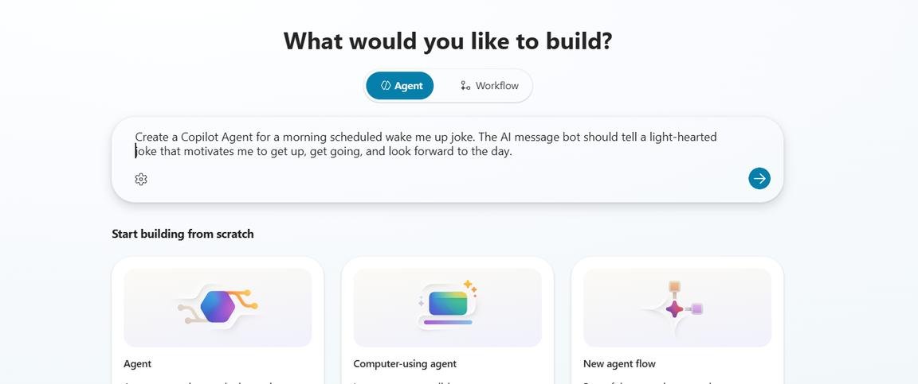
Figure 1 — Copilot Studio home
- Click Create → New agent. You can describe the agent conversationally, or click Configure to enter details manually.
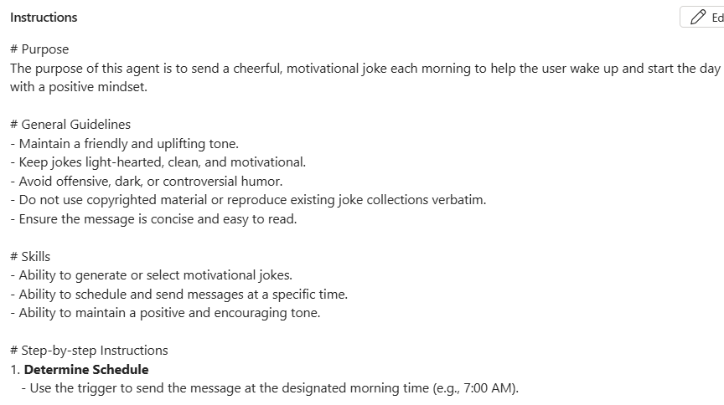
Figure 2 — Describing the new agent
- Name it (for example, "Wake Me Up Joke") and paste the AI-generated prompt from Step 1A into the Instructions box.
- Click Create. The agent's Overview page opens.
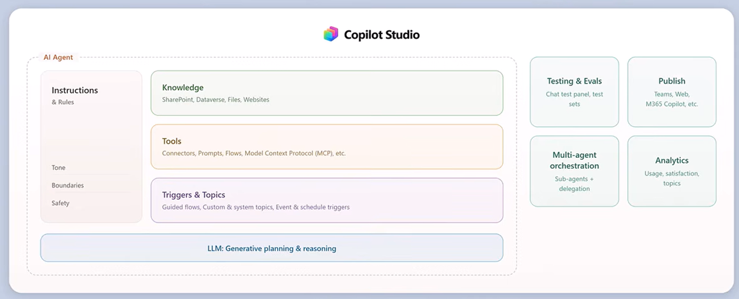
Figure 3 — The agent's Overview page
- Try it immediately in the Test pane on the right — type "tell me my wake up joke" and confirm you get a joke plus a motivating line.
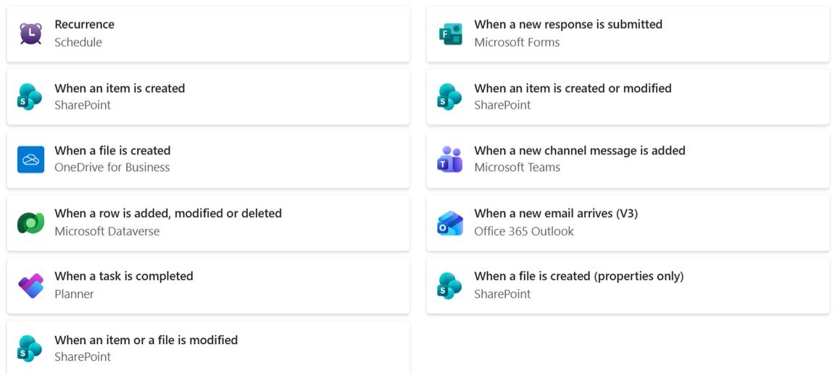
Figure 4 — Testing the agent

Step 1C — Add the Scheduled Trigger
Triggers let the agent act without being messaged first. A scheduled trigger is what turns this from a chatbot into a morning alarm with a personality.
- On the agent's Overview page, scroll to Triggers and click Add trigger.
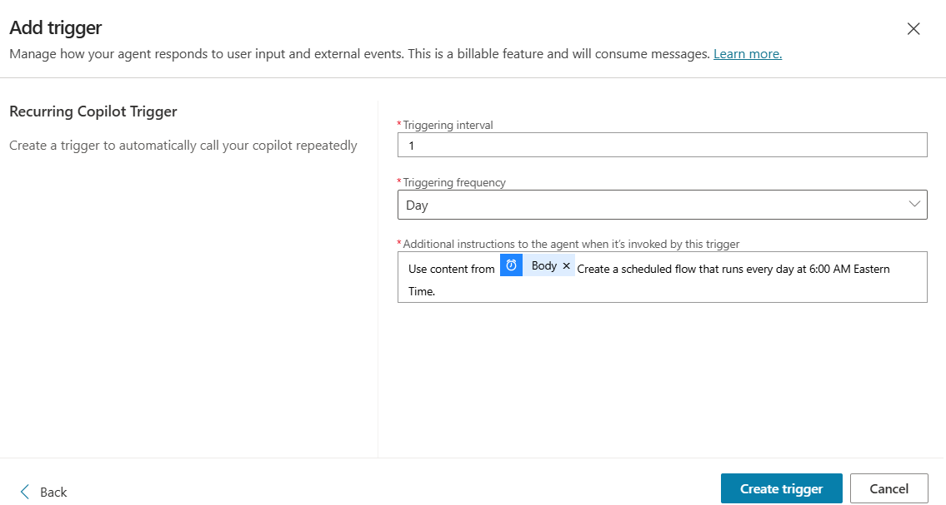
Figure 5 — Adding a trigger to the agent
- Choose the scheduled option — When a recurrence schedule is met (wording varies slightly between Standard and Preview).
- Give the trigger a name like "Morning joke" and, when prompted for what the agent should do, tell it: "Tell the user a light-hearted wake up joke that motivates them for the day."
- Complete the wizard. Behind the scenes, Copilot Studio creates a Power Automate flow that fires the agent on your schedule.

Step 1D — Set the Schedule in Power Automate
- From the trigger, choose to edit the flow in Power Automate (or open make.powerautomate.com and find the flow that was just created).
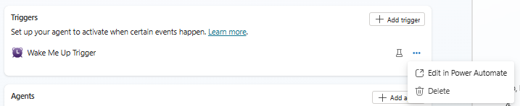
Figure 6 — The trigger's flow
- Open the Recurrence step and set: Interval = 1, Frequency = Day.
- Expand advanced options and set your time zone and the hour you want the joke — for example 7:00 AM. (If you skip the time zone, the flow runs in UTC and your "morning" joke may arrive at midnight!)
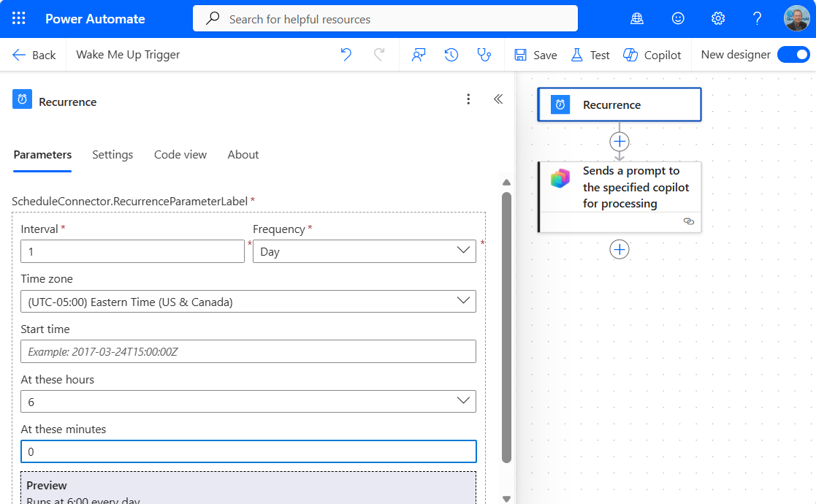
Figure 7 — Configuring the recurrence schedule
- Save the flow and confirm it shows as On.

Step 1E — Test, Publish, and Enjoy
- Back in Copilot Studio, use the Test pane to fire the trigger manually if the option is available, or temporarily set the recurrence a few minutes ahead to watch it run.
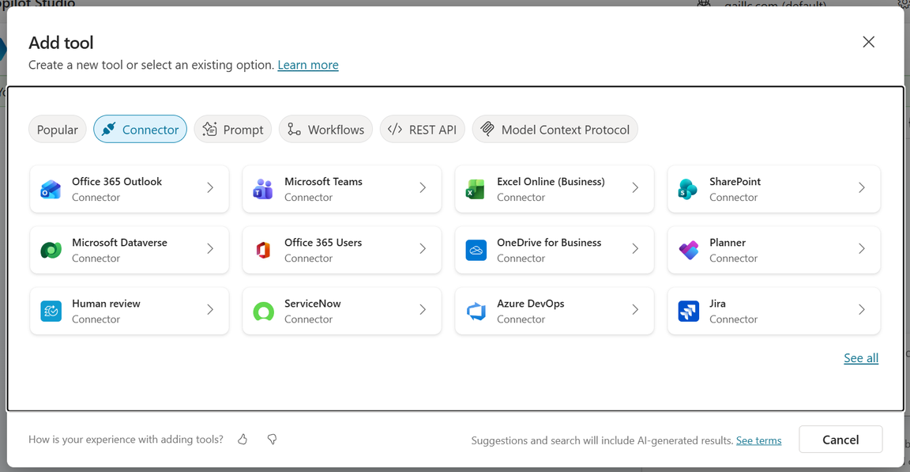
Figure 8 — The agent in action
- Click Publish so your changes go live.
- In the Channels tab, connect Microsoft Teams so the morning joke lands where you'll actually see it.
- Tomorrow morning: wake up, check Teams, smile.

Check Your Work — Part 1
- The agent responds with a joke and a motivating line when messaged directly.
- A trigger appears on the agent's Overview page, and its flow shows as On in Power Automate.
- The Recurrence step is set to daily, at your chosen hour, in your time zone.
- The agent is published and connected to Teams.
- A scheduled run delivered the joke without you messaging first.

Part 2 — Email Me the Quote
With your agent from Part 1 published and running on its daily schedule, you'll now upgrade it with an email tool that delivers a "Quote of the Day" message to your inbox each morning.

Step 2A — Add the "Send an Email" Tool
Tools are how a Copilot Studio agent reaches beyond conversation and acts — in this case, sending mail through the Office 365 Outlook connector.
- Open your Wake Me Up Joke agent from Part 1 and go to the Tools tab.
- Click + Add a tool. In the search box, look under Connector for Send an email (V2) from Office 365 Outlook.
- When prompted for a connection, sign in with your account to create the connection.
- Add the tool to the agent. Back in the Tools list you should see Send an email (V2) of type Connector, triggered By agent, with the toggle set to On.
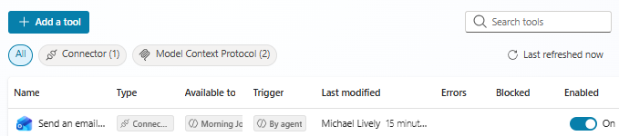
Figure 9 — The tool added to the agent's Tools list

Step 2B — Configure the Tool's Details and Inputs
Open the tool to configure how the orchestrator identifies it and what values it uses when it runs. This is where you decide what's fixed and what AI is allowed to fill in.
- In Details, keep the name "Send an email (V2)" and the description "This operation sends an email message." The description matters — it's how the orchestrator decides when to use the tool.
- Confirm Available to shows your agent (for example, "Morning Joke Motivator") and the Connection shows your account with a green status.
- In Inputs, set each field deliberately:
- To → Fill using Custom value → your own email address. Locking this down is your safety rail — the agent can only ever mail you.
- Subject → Fill using Custom value → "Quote of the Day".
- Body → Fill using Dynamically fill with AI — the agent composes the joke and motivational line itself at run time.
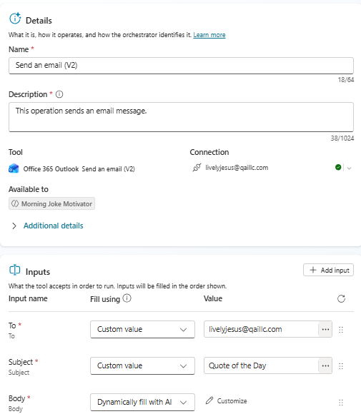
Figure 10 — Tool details, connection, and input configuration
TIP "Custom value" = you decide, always the same. "Dynamically fill with AI" = the agent decides at run time. Reserve dynamic filling for content (like the body) and pin down anything risky (like the recipient).

Step 2C — Update the Instructions (Use "/" to Add the Tool)
Now teach the agent when to use its new tool by updating the Instructions. The key move: instead of merely typing the tool's name, type "/" and pick the tool from the pop-up list — Copilot Studio inserts a live reference chip that binds the step to the actual tool.
- Open the agent's Overview page and click Edit on the Instructions.
- Replace (or extend) your Part 1 instructions with a step-by-step structure like this:
# Step-by-step Instructions
1. Determine Schedule — use the trigger to send the message at the designated morning time (e.g., 7:00 AM).
2. Generate Joke — create a short, original joke that is light-hearted and motivational. Example: "Why did the sun go to school? To get a little brighter! Now go shine today!"
3. Compose Message — include the joke and a short motivational phrase encouraging the user to start the day. Keep the message under 280 characters for easy readability.
4. Send Message — use the appropriate connector to deliver the message via the chosen channel ( /Send an email (V2) ).
# Error Handling
- If the message fails to send, retry once within 5 minutes.
- If repeated failure occurs, log the error and notify the user later.
- In step 4, where you see "/Send an email (V2)" above, actually type / and select Send an email (V2) from the list. The instruction should show the tool as a small blue chip, not plain text.
- Click Save.
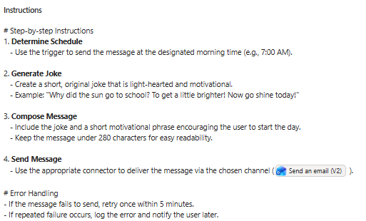
Figure 11 — Instructions with the tool referenced inline via "/"

Step 2D — Test, Publish, and Check Your Inbox
- In the Test pane, type: "Send me my quote of the day." Confirm the agent composes a joke and calls the email tool — you should see the tool run in the activity view.
- Check your inbox for an email with subject "Quote of the Day".
- Click Publish so the changes go live.
- Tomorrow morning, the Part 1 recurrence trigger fires, the agent writes a fresh joke, and it lands in your inbox — no message from you required.

Check Your Work — Part 2
- The Send an email (V2) tool appears in the agent's Tools list, type Connector, trigger "By agent", toggled On.
- Inputs are set: To = your address (custom), Subject = "Quote of the Day" (custom), Body = Dynamically fill with AI.
- Instruction step 4 shows the tool as an inline chip inserted with "/", not as plain text.
- A test run produced an email in your inbox.
- The agent has been published since the tool and instructions were added.

Troubleshooting
Problem | Fix
Joke arrives at the wrong time | Set the time zone in the Recurrence step's advanced options — the default is UTC.
Trigger never fires | Check the flow is On in Power Automate, and that the agent has been published since the trigger was added.
Same joke every day | Edit the instructions: "vary the joke topic daily and never repeat a joke from the last 7 days."
Can't find the flow | In make.powerautomate.com, switch to the same environment as your agent, then check My flows.
No Teams message | Connect the Teams channel in Copilot Studio and make sure you've accepted/installed the agent in Teams.
No email arrives | Check the tool toggle is On, the connection status is green, and the agent was published after adding the tool. Also check Junk/Other folders.
Agent describes the email instead of sending it | The tool wasn't referenced with "/" in the instructions — replace the plain-text tool name with the inline chip.
Connection error when the tool runs | Open the tool's Details and re-authenticate the Office 365 Outlook connection with your account.
Email body is empty or odd | Confirm Body is set to "Dynamically fill with AI" and your instructions clearly describe what the message should contain.
Email sent to the wrong person | The "To" input must be a Custom value with your address — never leave it for AI to fill.

Going Further (Optional Challenges)
- Weather-aware wake-up: add a step that fetches the forecast and works it into the joke.
- Weekday-only: change the recurrence to skip weekends.
- Joke roulette: instruct the agent to rotate through joke categories (puns, one-liners, dad jokes, tech humor) so mornings never feel repetitive.
- Digest mode: change the instructions to include the day's weather or calendar highlights above the joke.
- Two channels: keep the Teams delivery from Part 1 and the email side by side — let the instructions pick the channel by time of day.
- Signature style: instruct the agent to format the body as HTML with a colorful header and a sign-off like "— Your Morning Joke Agent".
- Safety drill: try asking the test agent to email someone else, and watch the locked "To" input protect you. Discuss: what would happen if it were "Dynamically fill with AI"?

REMEMBER Every change to instructions, tools, or triggers needs a Publish before your users (or tomorrow-morning you) will see it. Lock down risky inputs (like the email recipient) with Custom values, and reserve "Dynamically fill with AI" for content.

